Exercise 1

> mean

PPk_Stk PBB_Stk PFl_Stk PHse_Stk

0.5184362 0.5432103 1.0150201 0.4371477

PGen_Stk PImp_Stk PSS_Tub PPk_Tub

0.3452819 0.7807785 0.8250895 1.0774094

PFl_Tub PHse_Tub

1.1893758 0.5686734

> var

PPk_Stk PBB_Stk PFl_Stk

0.0226554865 0.0144797566 0.0018399974

PHse_Stk PGen_Stk PImp_Stk

0.0141208621 0.0012366513 0.0131437214

PSS_Tub PPk_Tub PFl_Tub

0.0037468593 0.0008836431 0.0001975293

PHse_Tub

0.0052497277

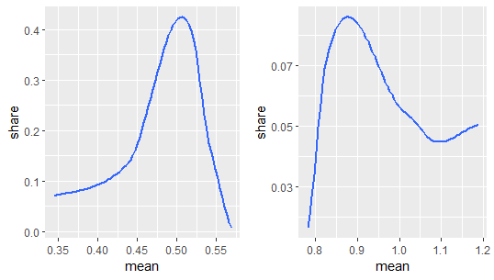

|  | **choice** | **Income** | **Fs3_4** | **Fs5.** | **Fam_Size** | **college** | **whtcollar** |
| --- | --- | --- | --- | --- | --- | --- | --- |
|  |  |  |  |  |  |  |  |
| **1** | 1 | 26.71291 | 0.5107588 | 0.13703284 | 3.174972 | 0.3176670 | 0.5702152 |
| **2** | 2 | 26.06581 | 0.5150215 | 0.11158798 | 3.101574 | 0.3133047 | 0.5436338 |
| **3** | 3 | 30.70988 | 0.2551440 | 0.08230453 | 2.481481 | 0.4526749 | 0.5432099 |
| **4** | 4 | 27.64334 | 0.5025295 | 0.19898820 | 3.470489 | 0.2934233 | 0.5919056 |
| **5** | 5 | 26.44444 | 0.5936508 | 0.20000000 | 3.692063 | 0.2730159 | 0.7142857 |
| **6** | 6 | 39.15541 | 0.2432432 | 0.31081081 | 3.175676 | 0.4324324 | 0.5675676 |
| **7** | 7 | 25.32132 | 0.4921630 | 0.06269592 | 2.890282 | 0.3228840 | 0.5768025 |
| **8** | 8 | 34.24877 | 0.6009852 | 0.05418719 | 3.093596 | 0.2561576 | 0.5714286 |
| **9** | 9 | 31.90000 | 0.3022222 | 0.04888889 | 2.386667 | 0.2755556 | 0.5777778 |
| **10** | 10 | 29.46970 | 0.3636364 | 0.54545455 | 4.424242 | 0.4545455 | 0.9393939 |

Showing 1 to 10 of 10 entries, 7 total columns

Exercise 2, 3, 4

I use conditional logit model to build the association between price and demand. beta=-2.428201, increase in price will decrease the demand of stick and tub ceteris paribus, marginal effect=-0.288312.

use multinomial logit model to build the association between family income and demand, and I find that increase in family income will decrease the demand of stick and tub.

alpha for different choices:

2.5131249 1.5822821 -0.0982038 1.1309081 0.8362109 -1.2326746

0.9147475 1.8785466 0.3087046 -0.3448824

beta for different choices:

-4.9142813 -4.9240848 -4.8558465 -4.8927522 -4.9162019 -4.8609748 -4.9226228 -4.9302601 -4.8717102 -5.4285383

Exercise 5

MTT=-43601.75 based on chisq(df=19) test, IIA is violated